Created - Train And Test Folders

**Team ID: PNT2022TMID31248 Project Name:** Real time communication system powered by AI for specially abled

PNT2022TMID25445

Stage 1: D:\IBM PROJECT – AI

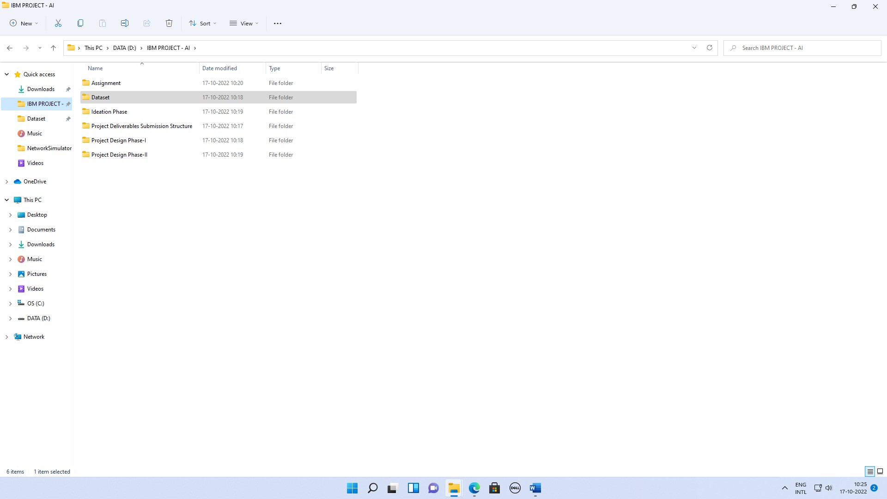

**Real-Time Communication System Powered by AI for Specially Abled -PNT2022TMID31248**

**PNT2022TMID25445**

Team Members: LINGAKUMAR M,

HARISH BALAJI P

**LOGESH G**

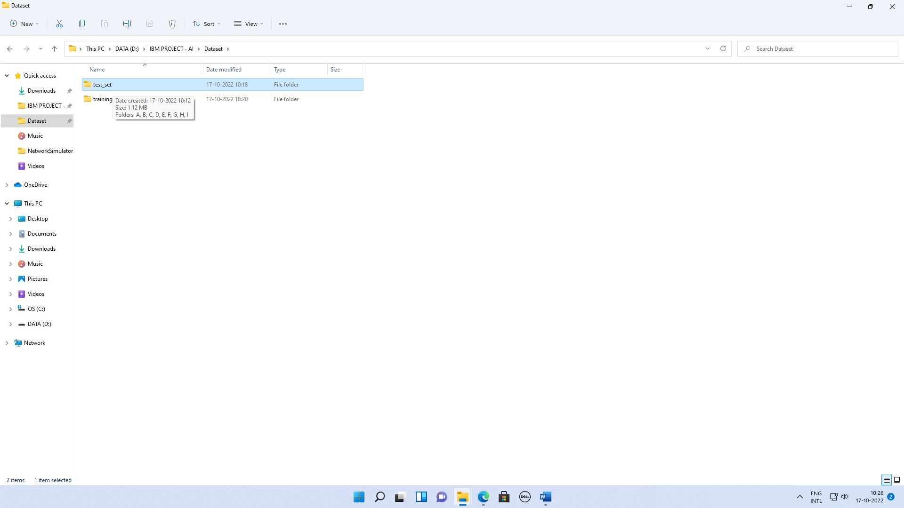

# Real-Time Communication System Powered by AI for Specially Abled - PNT2022TMID31248

**PNT2022TMID25445**

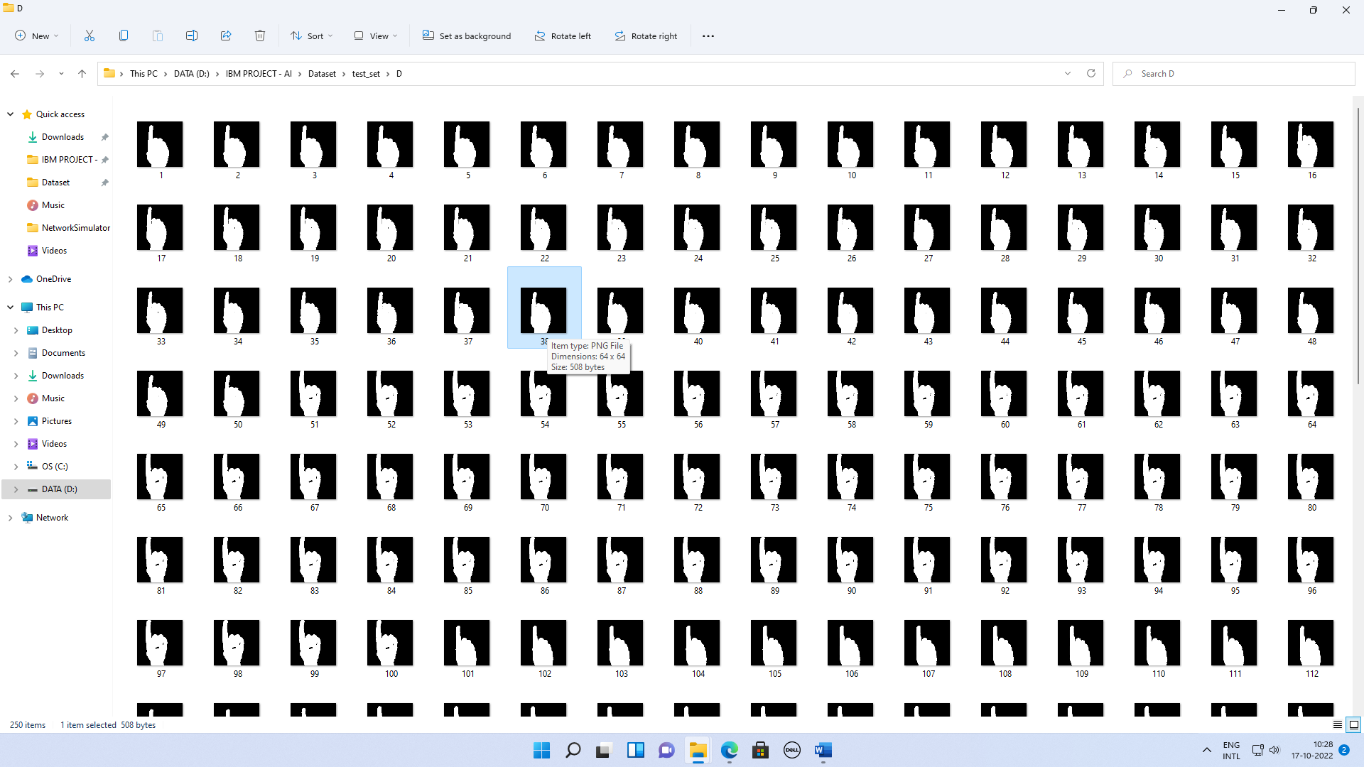

# Real-Time Communication System Powered by AI for Specially Abled - PNT2022TMID31248

**PNT2022TMID25445**

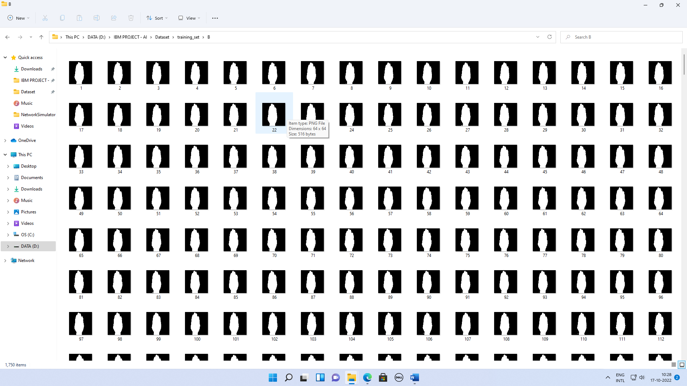

# Real-Time Communication System Powered by AI for Specially Abled - PNT2022TMID31248

**PNT2022TMID25445**